New Boone County Jail Entry Procedures for the Public
October 30, 2023

As we continue to work on the expansion of the Justice Center, we have new changes that will affect anyone wishing to complete business at the facility. Effective todays date the following instructions for entry into our facility will be utilized:
- Entry remains the main drive off of Indianapolis Avenue for police, fire, EMS, and general public.

- Please continue on the roadway towards the rear of the building. PLEASE USE CAUTION during the daytime as this is an active construction site with moving equipment.

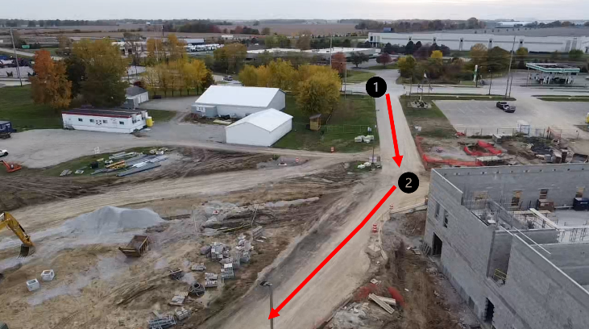

- As you travel across the rear of the property on the roadway, you will see a big brown barn with a gravel parking lot. This is parking for employees and other visitors.

- Please only park in this area, as other designated parking areas are being used for officers bringing in arrestees and other movements.

- You may then walk over to the ramp that leads to the 163 door. 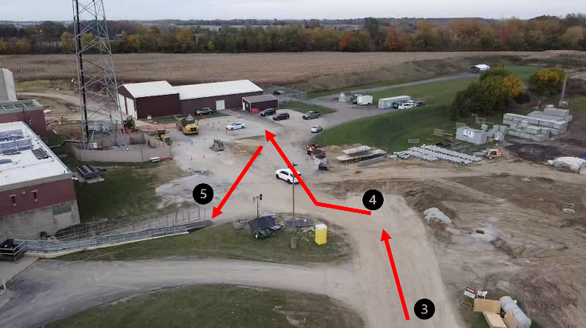
- Please be careful as you make entry up the ramp to the 163 door.

- There is a button on the wall that you must push to speak to a jail representative. A Corrections Officers or other staff will then meet you at the doorway to assist.

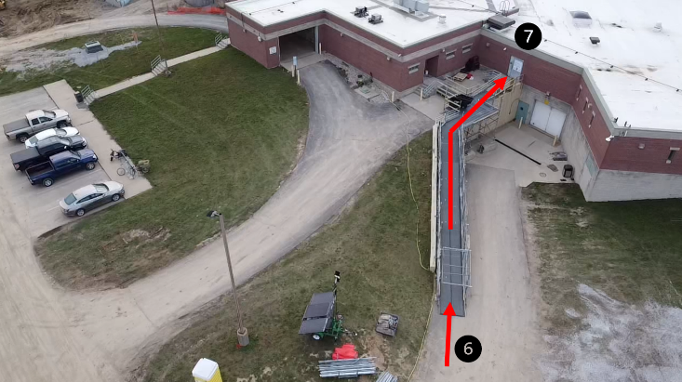

NOTE: If you are picking up an inmate being released, please park in the parking lot off Indianapolis Avenue (area depicted in yellow) in front of the jail construction area. The released inmate will meet you in that area.



